Supporting information

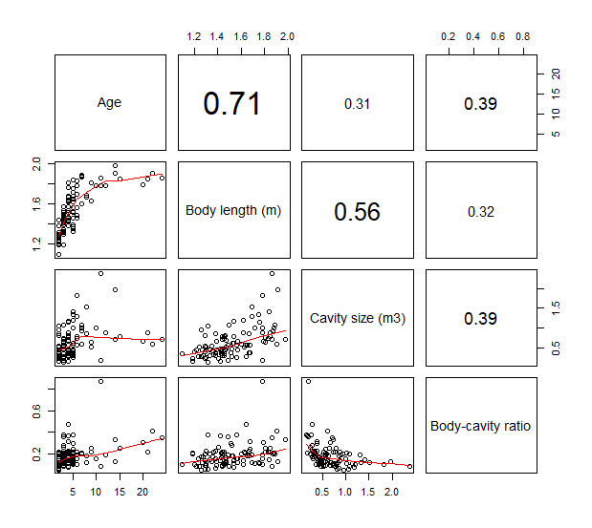
Figure S1. Multi-panel pairwise scatterplot of continuous variables used in the analyses of cavity size and body-cavity ratio of brown bears in Sweden during 1986-2016 (n = 86 from 62 solitary bears). Upper right panels show Pearson correlation coefficients.
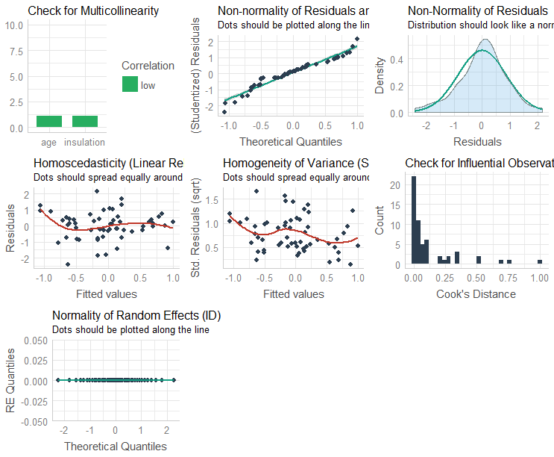
Figure S2. Model validation plots for the most parsimonious model predicting posthibernation body condition index of brown bears in Sweden during 1986-2016 (n=57 from 42 solitary bears).

