Fire effects:

**HF- Heat Fluxes**

RHF1-RHF4 – radiative heat flux sensor kW/m2

THF1, THF2 – convective and radiative heat flux sensor, temperature measurements from thermocouple welded on the surface of the steel plate kW/m2

Time – time for all heat flux sensors

Temp1 – temperature measurements from THF1 [oC]

Temp2 – temperature measurements from THF2 [oC]

**MFM- Mass Flow Meter**

time – time for mfr, P and T

mfr – mass flow rate measured at the coriolis mass flow meter [g/s]

P – pressure measured at the outlet of the Coriolis mass flow meter [bar]

T – temperature measured at the Coriolis mass flow meter (is not the gas temperature but the temperature of the Coriolis AND gas) [oC]

**Tank**

T – temperature measured in the tank (is not the exact gas temperature inside the tank since the thermocouple was installed inside the bolt, the heat transfer steel needs to be calculated [oC]

P – pressure measured at the tank outlet [bar]

Time – time for T and P

**TS – Temperature Sensors**

TT1-TT4 – thermocouples under the ceiling [oC]

TT6, TT7 – thermocouples under the car (front and back wheel) [oC]

TT8, TT9 – thermocouples from the wall (8 cm) between the car and the ventilation wall (‘behind’ the car) [oC]

TT5 – thermocouple from the wall (8 cm) ahead of the car [oC]

time – time for all TT

Trig – trigger

**Vent**

T – thermocouple inside the ventilation pipe [oC]

ACH – air change per hour [1/h]

vfr – volumetric flow rate [m3/h]

time – time for T,ACH and vfr

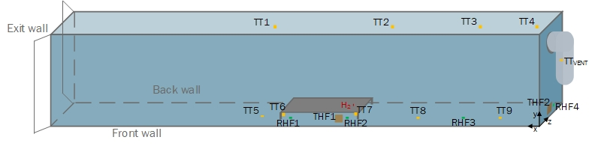

Table 2 Sensors’ location

130 mm

|  |  |  |  |
| --- | --- | --- | --- |
| Location parameters [mm] | | | |
|  | y | x | z |
| TT1 | 2105 | 6250 | 1120 |
| TT2 | 2105 | 2320 | 1120 |
| TT3 | 2105 | 1060 | 1120 |
| TT4 | 2105 | 110 | 1120 |
| TT5 | 235 | 7200 | 80 |
| TT6 | 198 | 6330 | 868 |
| TT7 | 200 | 4600 | 860 |
| TT8 | 235 | 3310 | 74 |
| TT9 | 235 | 1030 | 80 |
| RHF1 | 235 | 6080 | 40 |
| RHF2 | 220 | 4850 | 0 |
| RHF3 | 235 | 2300 | 40 |
| RHF4 | 235 | 40 | 1100 |
| THF1 | 75 | 5020 | 50 |
| THF2 | 95 | 0 | 750 |
| nozzle 45 | 180 | 4980 | 1120 |
| nozzle 90 | 230 | 5000 | 1120 |
| TTvent | 510 |  | 130 inside |

